*Welcome from Lucy Hubber, Director of Public Health*

Thank you for taking an interest in joining the Public Health Team at Nottingham City Council. We are so proud of our team and the wonderful work they do – we hope you find the information below gives you a bit of insight into who we are, what’s important to us, what we’ve collectively achieved and our next ambitions.

I joined Nottingham City Council four years ago. A quick google will show you that it is an organisation that is going through enormous transformation on an improvement journey. You can find out more in the [Improvement Plan](https://www.nottinghamcity.gov.uk/your-council/about-the-council/council-improvement-plan/). This willingness to think differently and be open to change has meant that we have been able to drive an exciting public health strategy across the council and the wider system to improve health outcomes for local communities.

The team have been leading amazing work that has had local and national impact. We are recognised as leaders in the effective use of the public health grant, reducing gambling related harm and integrating lived and living experience into commissioned services. We have turned the increasing trend in smoking rates and are proactive at reducing health inequalities. Our new Joint Local Health and Wellbeing Strategy will bring new focus onto best start in life and alcohol-related harm, alongside a continuing focus on work & health, smoking, eating and moving for good health and severe multiple disadvantage. These new consultant roles will lead across these areas to bring innovation, collaboration and change.

I’d love to talk to you more about our work and these opportunities. I hope you will think about joining us to help us make a difference

Lucy

*About the team*

|  |
| --- |
| **The public health team @ Nottingham City Council** |

Nottingham’s Public Health Team consists of 53 brilliant individuals, working together to be even more brilliant. The team currently includes four thematic portfolios led by Consultants in Public Health and one enabling portfolio (that makes it all work). Common job roles across the portfolios provide a clear structure, enabling people to join as an apprentice (we were delighted to welcome our first two – Destiny and Nicole – earlier this year) and work towards being our future Director, with clear development support. This means we can facilitate team members working in different portfolios over time, broadening their experience to support career progression and job satisfaction. Our team mission is to add public health value to every interaction, so we are proactive about professional development, reflective practice and seeking feedback.

*Who will you be working with?*

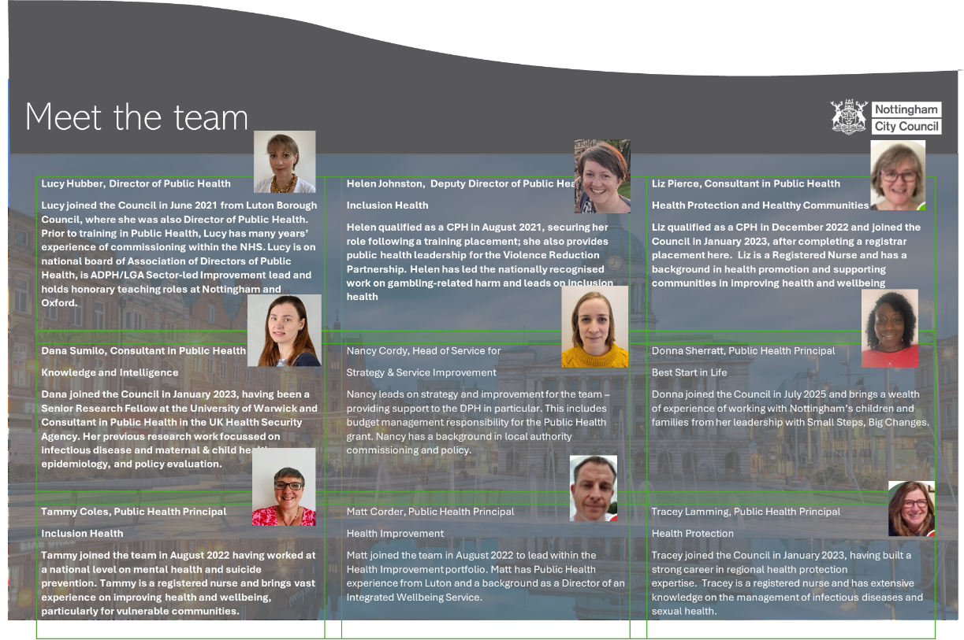

**What is important to our team and how does it help us achieve?**

*Making a difference*

First and foremost the team are motivated by making a difference to the health and wellbeing of people in Nottingham, particularly those who unfairly experience the poorest health outcomes. Nottingham has some of the lowest life expectancy figures in the country so there is a lot to do.

Big changes have been made to the way we present our joint strategic needs assessment (JSNA), to better enable us (and others) to identify priority areas and actions.

In the last year we’ve:

* Published the first [two JSNA dashboards](https://www.nottinghaminsight.org.uk/themes/health-and-wellbeing/joint-strategic-needs-assessment/) – giving users easily accessible key data to inform decision making – with more in the pipeline.
* Developed a new product ‘JSNA profiles’ – the first of which explored the health and wellbeing of [people seeking asylum, refugees and people refused asylum](https://www.nottinghaminsight.org.uk/themes/health-and-wellbeing/joint-strategic-needs-assessment/adults/people-seeking-asylum-refugees-and-people-refused-asylum-2024/). This work informed the commissioning of a new service as well as raising the profile of this topic at a system level.
* Held a series of focus groups to inform our first ever Women’s Health Needs Assessment, due to be published shortly. It’s been a real team effort to organise, recruit, facilitate and analyse the data.

*Inclusivity and diversity*

The team serves a diverse community with diverse needs. We proudly champion the need to do more or different for some groups to address inequity.

* The team has grown significantly (from 5 to over 50) in recent years. A deliberate effort to recruit for potential (with innovations made to our recruitment processes) has contributed to a more diverse team. Both demographically (meaning we more closely represent the community we serve) but also in terms of background, experience and skills. The team now includes previous nurses, teachers, social workers, researchers and more. This breadth of experience enables us to learn from and constructively challenge each other, ultimately improving the quality and impact of our work.
* The team promotes and practices the value of seeking, listening to and learning from lived experience of the issues we are seeking to address, in order to understand need and identify barriers, develop effective strategies and services, and avoid unintended consequences.

This year we’ve:

* Held engagement sessions in communities with lower vaccination uptake, resulting in locally tailored resources and a newly commissioned catch-up service and community-based vaccination sessions. The insight gained has helped secure additional financial resource from system partners and numbers vaccinated are going up, so we know it’s working.
* Recruited, trained, nurtured and engaged with 100s of community champions, representing different groups and communities across Nottingham, leading to an inspirational celebration and award event in December 2024.
* Published and launched our annual public health report exploring the impact of stigma on health and wellbeing, including a range of practical tools to help individuals and organisations make changes - [Public Health - Nottingham City Council](https://www.nottinghamcity.gov.uk/information-for-residents/health-and-social-care/adult-social-care/public-health/)
* This builds on good practice undertaken within the team, ensuring that lived experience was pivotal to informing our campaign to raise awareness of gambling related-harm and its impacts. The campaign saw 30 times more visits to the local webpage signposting individuals to support. We are now recognised nationally as leaders on this topic!

*Being kind*

Kindness is a core value for team colleagues. Kindness is proactively fostered through team engagement, shared training, buddy relationships. We celebrate this through our annual jar of kindness where colleagues recognise the kindness and show appreciation to colleagues throughout the year.

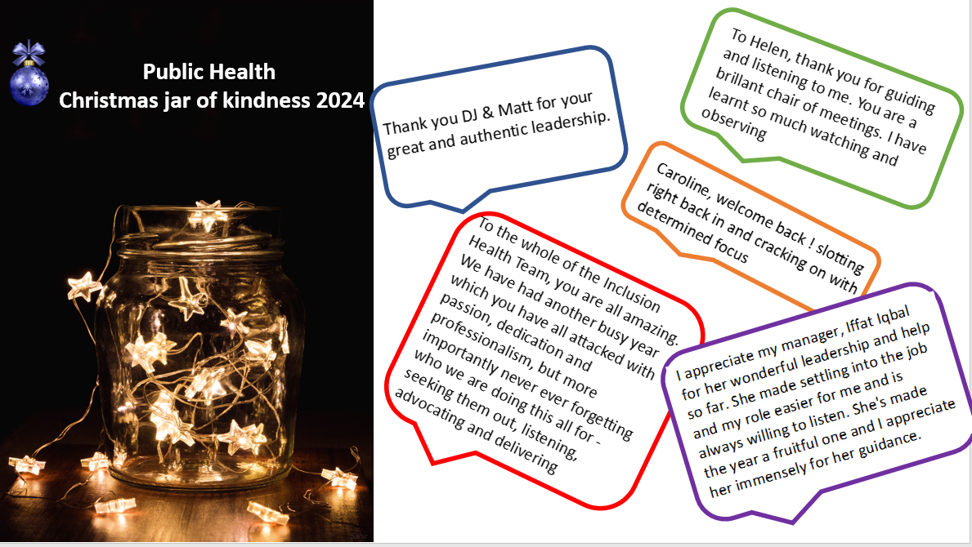

This year we have:

* Further strengthened our recruitment processes to let applicants’ potential shine. This includes holding information events so people can hear from those already doing the job and sharing a pre-interview information pack full of hints and tips. A ‘meet the team’ element gives those who might join us the chance to get a feel for who we are and how we work, with positive feedback from team members and those being interviewed. Collectively this has raised our profile as a team that people want to work for.
* Implemented a policy to support the wellbeing of colleagues working with sensitive data such as information relating to suicide or drug related deaths, recognising the impact this may have on us as caring individuals.

*Collaborative learning*

Continued professional development is a really important part of being a public health practitioner. There is a strong emphasis on learning from each other, with fortnightly organised opportunities for the team to share their work focussing on reflection and lessons learned. Colleagues from across the team lead sessions for their peers as part of our quarterly development days – we are never short of volunteers.

This year we have:

* Supported 18 colleagues to study Masters modules at the University of Nottingham with some brilliant results achieved
* Benefited from colleague-generated and led initiatives – including a piece of work to identify opportunities for cross-portfolio collaboration to ensure our health improvement offer meets the needs of inclusion health groups
* Developed a professional practice portfolio to support the learning and development of all colleagues in the team.

We are a vibrant, quality training location, with a full complement of registrars. Consultants in Public Health are encouraged and supported to become Educational Supervisors and participate in regional Train the Trainer sessions, to share learning, develop skills and networks. Through our healthcare public health approach, we also provide in-reach support to a number of NHS provider trusts to develop their professional practice.

Additionally, our philosophy is that Consultants in Public Health should contribute back into the wider public health workforce and policy system, so encourage training as professional appraisers or mentors and participate in national policy and special interest groups.

*Improving outcomes*

The team is going from strength to strength and we are immensely proud of the progress we’ve collectively made. Public health outcomes take time to shift but there are positive signs – including a reduction in smoking rates (from 21.2% to 18.2%) meaning we have improved from having the second highest rates nationally.

We developed and delivered our Joint Local Health and Wellbeing Strategy 2022-25 with local communities and system partners. We intentionally focused on the most challenging areas that required collective partnership action, including smoking & tobacco control, eating and moving for good health, financial wellbeing and severe multiple disadvantage and have made good progress in a sustainable way (see figure below).

Our commissioned services are a key route to delivery. In the last couple of years we have recommissioned a new model for substance use services and a new integrated sexual health service; commissioned an integrated wellbeing service, Thriving Nottingham, a healthy school service, Achieve Well and an oral health service. Additionally, we are finding new ways to use our resources to support communities in finding their own solutions, through grant programmes and a community champion approach. We are seeing the impact of these services in improved outputs and outcomes. In the next couple of years, we will be commissioning the new best start in life service.

We continue to be ambitious for the future with an updated JLHWS and additional capacity to support research and evaluation both within the team and across the Council. We have mutual learning arrangements with University of Nottingham and Nottingham Trent Universities, with areas of joint research and honorary teaching contracts.

