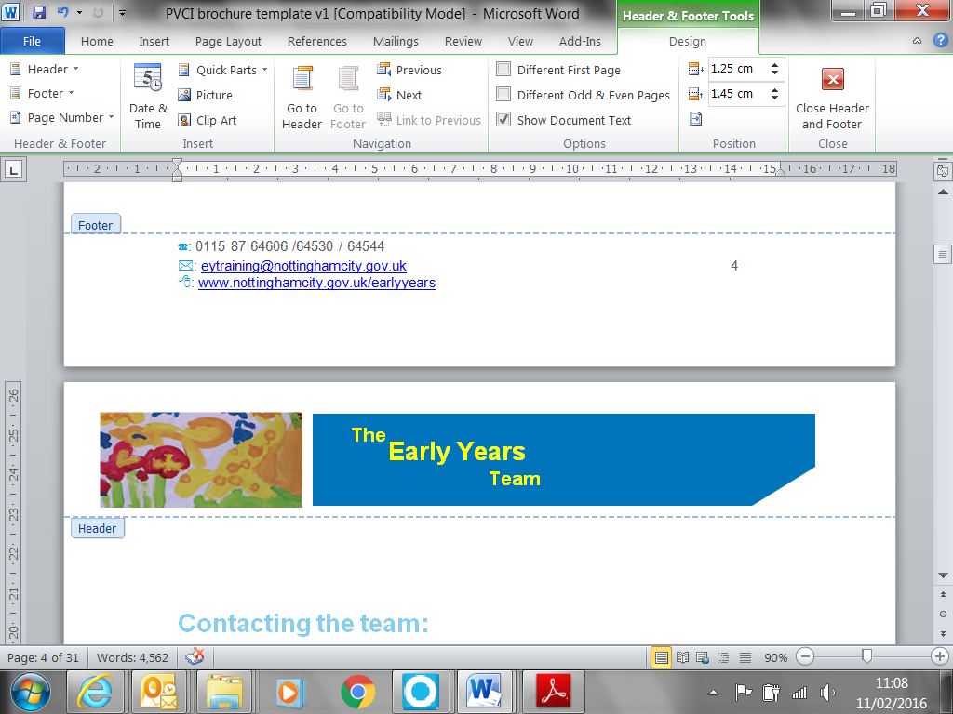
April 2026



Disability Access Fund (DAF) and EYPP

CPD and Resource Ideas

Contents | Page
Disability Access Fund introduction and CPD ideas | 3
Toys and Equipment for indoor and outdoor play | 4/5
Being Creative | 6
List of possible resources ( Rutland County council) | 7 - 9
Useful websites, Equipment and Craft products | 9
Further useful websites | 10

Disability Access Fund (DAF) Resource Ideas
Introduction:
This booklet has been created to give you some ideas of how the £975.00 Disability Access Funding (DAF) can be utilised. DAF can be claimed for any child in receipt of Disability Living Allowance (DLA) and accessing an Early Years Extended Entitlement place from 9 months to 4 years.
The (DAF) funding could be used to support you in making reasonable adjustments to your setting or help with building capacity, be that for the child in question or for the benefit of children as a whole attending the setting. In addition, it could be used for staff training, 1:1 support, or to purchase sensory or specialist services or equipment for the children who are eligible.
www.nottinghamcity.gov.uk/earlyyears/section-pages/equality-and-inclusion/early-years-send-fund-disability-access-funding/
These ideas could also be used as a way of evidencing your EYPP funding to support child development, learning and care for disadvantaged children.
See the provider agreement for criteria of the EYPP (page 16 section 3.5) 2026-27 Provider Agreement

Early Years CPD

SENCO Network: The SENCO specific annual membership enables appointed SENCO role holders (up to two per setting) to attend the three network meetings. These provide valuable networking opportunities whereby members can share good practice ideas, they also feature specialist guest speakers.

To find out more and download the membership form go to:
www.nottinghamcity.gov.uk/earlyyears/section-pages/cpd-training/cpd-opportunities-20242025/nottingham-city-senco-networks/

Introduction to SEND: This two hour on line introductory course developed by the Early Years Team is for Practitioners who do not currently have a SENCO Role but would like to increase their knowledge of Special Educational Needs and Disabilities.

New To SENCO: This two hour on-line workshop will provide practitioners with key points and practical ideas to help in the SENCO role. This will include investigating how the SENCO role is delivered across the city, discussions around early identification of children with additional needs and exploring the Graduated Response.

Being a SENCO: This two hour on-line course giving practical ideas has been developed by the EY team and certificated by UK CPD is for established SENCOs and will support you to identify small steps for learning, set SMART targets and complete individual provision maps. It will support SENCOs to understand their responsibilities to children with SEND and the setting’s approach to identifying and meeting SEND.

For more information on any of the above courses and other training available please go to:
www.nottinghamcity.gov.uk/earlyyears/section-pages/cpd-training/cpd-opportunities/

Toys and Equipment for Indoor and Outdoor Play

The items below will support children with a range of disabilities, also see page 10 and 11 for stockists and useful websites.

If you require any further support or advice for a specific child, please do not hesitate to contact Mel Foulston or Sam Caig the early years SEND setting support workers.

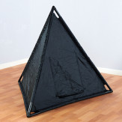

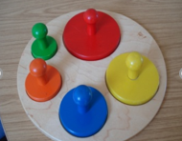

Large peanut balls

Sensory lighting kit
Easy hold shaped puzzles
Pyramid sensory dark den
Sensory massage toys
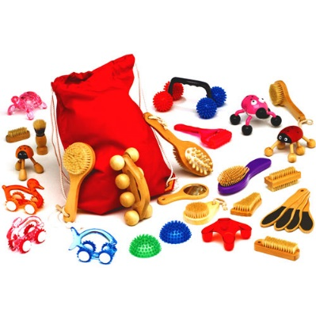
Large peg boards
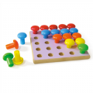
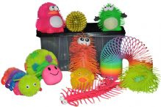

Tactile fidget hamper
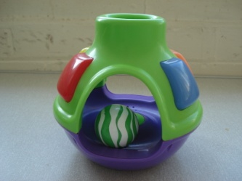

Single round hole posting
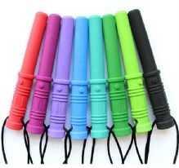
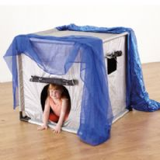

Ark bite saber sensory Chewlry
Dark Den
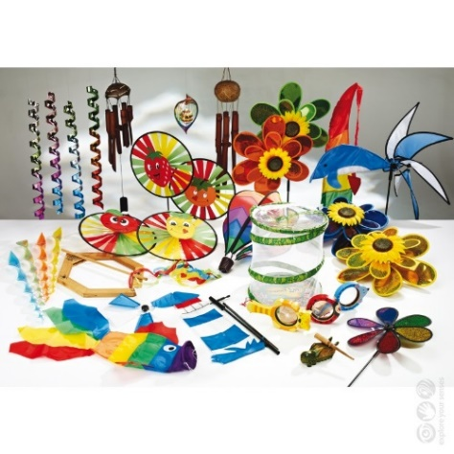
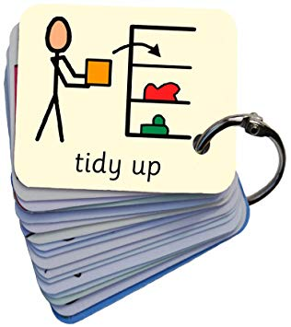

Wind Movement toys
Exchange cards- pre-school

Being Creative
To enable you to use your funding to go that little bit further, giving you chance to pay for staff training as well as resources here are a few ideas to develop a range of low cost resources.
This equipment can be used for Attraction or Distraction purposes with children on the Autism Spectrum, children with EAL or who are none verbal.
- Collect a range of the items (some examples below) and place in a small bag, tin or box to create an element of surprise. This makes a great interaction tool using either a ‘ready steady go/blow’ technique or copying what the child does with the toy.
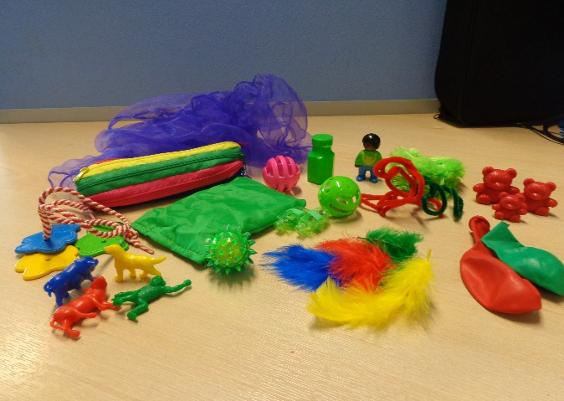
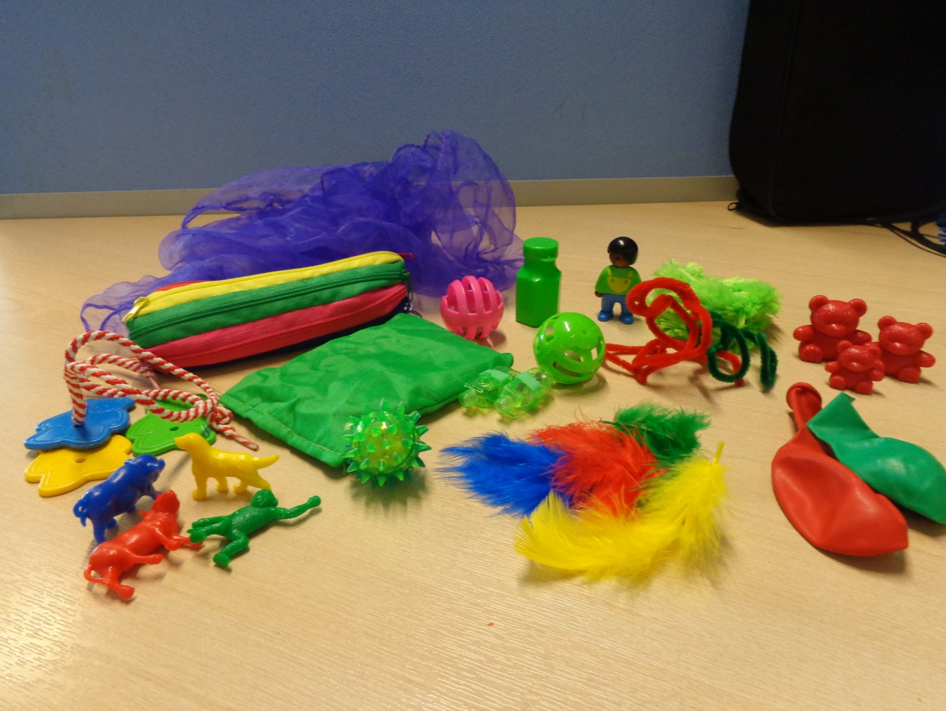
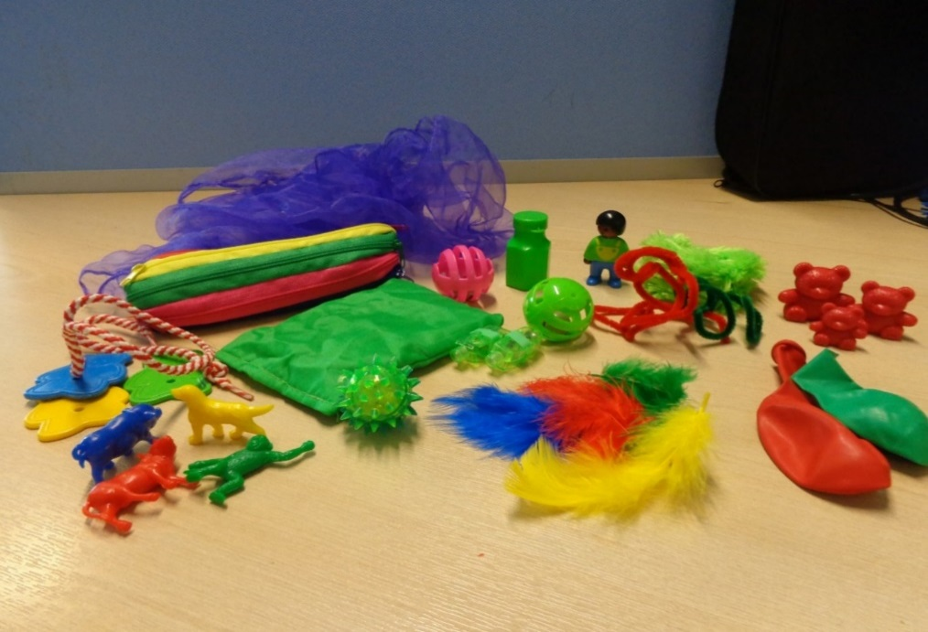
Chiffon scarf bean bags,
Feathers

Pipe cleaners, wool etc.

Bubbles
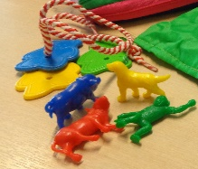
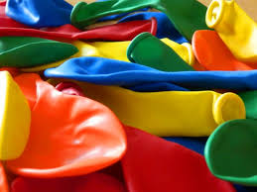

Balloons
Toy figures

- Use balls with bells inside or finger lights to attract a child with Autism who may seem as if they are in a world of their own. We need to find out what toys they like best and use these items to attract them to other areas in the setting, for example if they like letters and numbers put these in different areas such as in the sand, water or even in the home corner pans and point to them naming them out loud.
Balloons

Resource list from Rutland County Council
Physical access  • Gates/child gates  • Tarmac area for smooth access  • Ramp  • Handrails  • Steps  • Box for feet  • Chairs/seating  • Walker/rollator  • Outside equipment – different swing seat, adapted trikes, trikes with waist straps, resources to support to access the outdoor area  • soft play equipment  • sitting wedges  • corner seats  • visual support for sitting e.g. carpet spot  • Equipment for marking steps etc.  • Different chairs  • Big physio balls  • OT equipment e.g., spinning mat,  • Different types of scissors (e.g. table top scissors)  • Gross motor skills equipment  • Hoists  • Recording switches  • Bibs/dribble bibs  • Complete waterproof suits etc  • Tough spots etc – allowing physical/sensory play  • Chunky crayons/finger crayons  • Rulers with handles  • Early Pencil grips  • Suction grab rails  • High visibility jackets/bibs  • Push chair for trips  • Happy pee bottle | Communication needs/ASD  • Feelings faces  • Visual support  • Sensory tent  • Sensory toys  • Portable dividers – create different spaces  • Autism friendly materials – social stories book, weighted lap blankets  • Board maker/Communicate in Print CD or I-pad app.  • Sound area – head phones and DVD player etc. – calming or S+L  • Communication support – Makaton symbols, choice boards,  • DVDs for songs, simple, picture books  • big books and little books  • story sacks  • chunky books  • PECS books,  • storage for symbols (boxes or shelves)  • Chewy chews  • Mirrors for SLT  • Mini trampolines  • Persona dolls  • Enclosed chairs  • Key fobs – play doctor website  • Feely bags  • Early language objects (doll, brush, cup etc.)  • Parachute  • Visual timetables
Hearing needs  • Sign language books, cards and games  • Light and sound toys  • interactive whiteboards,  • Talking tins  • Acoustic modification:  • fabric for tables  • curtains  • hanging mobiles  • acoustic clouds  • carpet for a setting/rugs  • felt pads for bottom of toy boxes to reduce sounds  • sign and write – part of communicate in print software  • Velcro  • story sacks  • Listening games  • iPad – communication/pictures | Visual needs  • VI list – advice from sensory team to settings  • Books with sound buttons, tactile patches  • Touch Braille letters  • Coloured glue sticks  • Giggly Wiggly balls/sensory balls  • Tactile books  • Story sacks  • Musical instruments  • Light and sound buzzers  • Scented playdough  • Scented pens and pencils  • Vibrating cushions  • Plate guard/plate surround  • Scooping bowl  • High contract tape  • Dark tent/cosy cave  • Dark room kit  • Be Active box  • Tactile Vibrations Sensory Starter Tub  • Simple Switches  • UV Dark Den Multi Sensory Glow Kit  • Fibre Optics  • Lightbox  • iPad and iPad stands  • Tactile letters with braille  • Torches  • Subscription for 3-d books  • Survival blanket/space blanket  • Talking Tins  • Wikki Stick/ pipe cleaners  • Braille Maths Blocks  • Braille ABC blocks  • Numicom  • Desk slopes  • Talking books from RNIB
Self-care  • Toilet access, changing table etc., changing mats, kneeling pads for staff, storage, toilet frames, toilet steps, toilet inserts, potties with arms/backs  • Feeding materials: non-slip mats, angled plates, cutlery, appropriate height tables. chairs, specialist cutlery, grasp bar, cups, mini food processor  Behaviour  • Sand timers Reward systems/charts/stickers  • Emotion cards, bottles, balloons,  • Worry monsters | General developmental needs  • Sensory toys  • Cause and effect toys  • Stage-not-age toys e.g. cause and effect, inset puzzles, shape sorters.  • Large handled brushes  • Musical instruments/hand bells  • Light weight rattles  • Peg men/spring pegs  • Stacking toys with magnets  • Bubbles  • Switches and cause and effect toys  • Sensory materials  • Construction toys  • Treasure baskets – exploration toys  • Playdough  • Tactile materials/water beads/slime/semolina • Posting boxes
Medical support  • Secure box for medication, plus mobile box for trips etc | General  • Printer, Laminator, Velcro!  • Environmental changes e.g. safe space, child gates, security doors, handrails, high vis tape for steps, non-slip paint for steps  • Digital camera  • Cookery equipment

Useful Websites for Sensory equipment and Craft Products
https://www.cosydirect.com/special-needs | www.completecareshop.co.uk
www.tts-group.co.uk/primary/sen-special-direct/sensory/ | Homepage - Best Toys 4 Toddlers
www.cheapdisabilityaids.co.uk | www.exploreyoursenses.co.uk
www.exploreyoursenses.co.uk | www.bigjigstoys.co.uk
www.sensetoys.com | www.smythstoys.com
www.sensorytoywarehouse.com | www.rompa.com
Lights
www.sensoryplus.co.uk | LED light balls, Shadow boards
www.maplin.co.uk | Star projectors, mini lasers
www.mathmos.co.uk | Small projector and other light effects
www.optikinetics.co.uk | Solar LED projectors, magnetic rotators and effects wheels
Creating Sensory Environments
www.spacekraft.co.uk | Pop up tents, projection brolly's, white projection hut
www.mikeayresdesign.co.uk | Projection brolly
www.sensoryplus.co.uk | Projection brolly
www.hope-education.co.uk | Black out pods and modular mansion pop ups
www.umbrellaheaven.com | Range of umbrella’s, rainbow, clouds, black or White Square
Fluorescent Materials
www.theglowcompany.co.uk | Glow in the dark and UV fluorescent materials, LED UV torches
www.uvgear.co.uk | Wide range of UV-reactive products, LED UV torch
Google for: | Rip stop nylon, fluorescent kite fabric doesn’t tear
Sounds
www.mesdirect.com | Musical instruments especially the ‘Thunderer’
www.drumsforschools.co.uk | Instruments
Smells
https://aromaprime.com | Vortex aroma cubes
www.rompa.com | Everyday aroma activity game
Sensory Stories
www.puppetsbypost.com | Wonderful puppets for themes and sensory stories
www.hobbycraft.co.uk | Local stores for craft supplies

